INTERNSHIP REPORT

Title of the Internship: Digital Goniometer
Organization Name: National Institute of Technology Raipur
Duration: 2 Months

Submitted by:
Aastha Kalra
Roll No.: 23111001
Semester: 5th
Session: 2025

Date Of Submission: 1st December, 2025

ABSTRACT

This internship project, carried out at the National Institute of Technology Raipur, focuses on the development of a low-cost and portable digital goniometer for physiotherapy and rehabilitation applications. Conventional manual goniometers commonly used in clinical practice are limited by human error, inconsistent readings, and the inability to record dynamic joint motion. Existing commercial digital goniometers, while more accurate, are often expensive and inaccessible to small clinics, rural healthcare centers, and individual users.
The primary objective of this project was to design an affordable yet accurate digital goniometer using dual MPU6050 inertial sensors and an Arduino-based microcontroller platform. The work involved hardware integration, calibration of sensor modules, implementation of angle-calculation algorithms using a complementary filter, and computation of the relative angle between two body segments in a single plane. Real-time angle measurements were displayed and validated against a traditional manual goniometer.
The project successfully demonstrates that reliable joint-angle measurement can be achieved at a significantly lower cost compared to existing market alternatives. The outcome highlights the potential for deploying this system in physiotherapy centers, remote health monitoring, and home-based rehabilitation due to its simplicity, portability, and affordability.

Table of Content

1. Introduction ............................................................................................. 1
1.1 Background of Internship .................................................................. 1
1.2 Objective & Importance of Internship ............................................. 1
1.3 Relevance to Biomedical Engineering ............................................. 2
2. Organization Profile .............................................................................. 3
2.1 Name and Location ............................................................................ 3
2.2 Overview of the Organization ........................................................... 3
3. Internship Details .................................................................................. 4
3.1 Duration ............................................................................................... 4
3.2 Department/Section Assigned ......................................................... 4
3.3 Daily/Weekly Work Schedule Summary ........................................ 5
3.4 Tools, Software, and Instruments Used ......................................... 7
4. Description of Project .......................................................................... 9
4.1 Project Title ......................................................................................... 9
4.2 Project Objectives .............................................................................. 9
4.3 Methodology ....................................................................................... 10
4.4 Algorithm and Software Development .......................................... 13
4.5 Results and Observations ................................................................. 17
4.6 Discussion of Results ......................................................................... 19
5. Learning Outcomes .............................................................................. 21
5.1 Technical Skills Gained ..................................................................... 21
5.2 Professional and Interpersonal Skills Learned .............................. 22
5.3 Understanding of Biomedical Industry/Workflow ........................ 22
6. Challenges and Solutions ..................................................................... 23
6.1 Difficulties Faced ................................................................................ 23
6.2 Solutions Implemented ...................................................................... 24
7. Conclusion ............................................................................................... 25
8. References ............................................................................................... 26

1. Introduction
1.1 Background of Internship
This internship was conducted at the National Institute of Technology (NIT) Raipur, under Dr. Shivangi Giri, providing exposure to applied research and practical implementation in the field of biomedical instrumentation. The program offered hands-on experience in designing and developing an engineering solution aimed at addressing a real clinical need. As part of the internship, the task assigned was the development of a digital goniometer, a device used to measure joint angles for physiotherapy and rehabilitation purposes. The project involved integrating sensors, embedded systems, and biomedical concepts to create a functional, cost-effective prototype suitable for clinical use.
1.2 Objective and Importance of Internship in the Curriculum
The objective of this internship was to bridge theoretical knowledge with real-world application by designing an affordable and accurate digital goniometer. Internships are an essential component of the biomedical engineering curriculum as they allow students to gain practical exposure, develop problem-solving skills, and understand industry standards. This project enabled the application of electronics, signal processing, and biomechanics concepts learned in coursework, fostering a deeper understanding of medical device development.
1.3 Relevance to Biomedical Engineering
Biomedical engineering focuses on applying engineering principles to solve healthcare challenges. The development of a digital goniometer directly aligns with this discipline, as it supports clinical assessment, rehabilitation monitoring, and patient mobility evaluation. By using MPU sensors, microcontrollers, and biomechanical analysis, this project demonstrates how engineering technology can improve diagnostic accuracy, enhance patient care, and expand access to affordable medical devices.

2. Organization Profile
2.1 Name and Location
National Institute of Technology Raipur (NIT Raipur)
G.E. Road, Amanaka, Raipur – 492010
Chhattisgarh, India
2.2 Overview of the Organization
The National Institute of Technology Raipur is one of India’s premier technical institutions, established in 1956 and later elevated to the status of a National Institute of Technology (NIT) in 2005. It is an autonomous public institute under the Ministry of Education, Government of India. NIT Raipur offers undergraduate, postgraduate, and doctoral programs across engineering, architecture, and applied sciences, with a strong focus on innovation, research, and interdisciplinary learning.
The institute houses well-equipped laboratories, advanced research centers, and a vibrant academic environment that encourages practical, project-based learning. Known for its emphasis on technological development and societal impact, NIT Raipur collaborates actively with industries and research organizations to promote hands-on training and skill development.
For biomedical engineering and related interdisciplinary fields, the institute provides robust support through specialized faculty, modern instrumentation facilities, and opportunities for real-world problem solving. The internship program at NIT Raipur allows students to engage in meaningful research and develop engineering solutions aligned with clinical and healthcare needs—such as the development of the digital goniometer undertaken in this project.

3. Internship Details
3.1 Duration
The internship was carried out over a period of two months, from 15th May 2025 to 15th July 2025. This duration provided ample time for understanding the project requirements, conducting research, developing the prototype, performing testing, and documenting the outcomes.
3.2 Department/Section Assigned
The internship was completed under the Biomedical Engineering Department at the National Institute of Technology Raipur. The department focuses on integrating engineering principles with medical sciences to solve healthcare challenges. During the internship, access was provided to laboratory facilities, sensor modules, microcontroller platforms, and technical guidance necessary for the development of the digital goniometer project.
3.3 Daily/Weekly Work Schedule Summary
Week 1: Orientation and Literature Review
- Introduction to the internship objectives and project expectations.
- Studied the basics of goniometry, joint biomechanics, and existing digital goniometer technologies.
- Reviewed MPU6050 sensor specifications, I²C communication, and Arduino interfacing.
Week 2: Hardware Familiarization and Initial Setup
- Assembled and powered the MPU6050 modules and Arduino Uno.
- Learned wiring connections for dual I²C sensors with different addresses.
- Conducted basic tests to read raw accelerometer and gyroscope data.
Week 3: Sensor Calibration and Data Processing
- Performed zero-offset calibration for both MPU6050 modules.
- Processed sensor values to calculate tilt angles in 2D.
- Implemented complementary filtering to improve measurement stability.
Week 4: Angle Computation and Joint Angle Measurement
- Calculated individual sensor angles and derived the relative joint angle.
- Tested system accuracy using controlled joint movements.
- Compared readings with a manual goniometer for validation.

Week 5: System Integration and Output Display
- Integrated code modules for data acquisition, and angle computation.
- Displayed real-time joint angles on the serial monitor.
- Explored options for Bluetooth/wireless transmission (optional).
Week 6: Prototype Optimization
- Worked on noise reduction, drift compensation, and sensor alignment.
- Designed simple mounting straps/enclosure for the sensors.
Week 7: Testing and Documentation
- Conducted repeated trials to evaluate precision and repeatability.
- Recorded performance data and observations.
- Prepared documentation, including methodology, results, and report writing.
Week 8: Final Review and Submission
- Finalized the digital goniometer prototype.
- Reviewed outcomes with faculty supervisor.
- Completed and submitted the internship report.
3.4 Tools, Software, and Instruments Used
Hardware / Instruments
- MPU6050 (IMUs) – Dual sensors for 2D angle measurement
- Arduino Uno Microcontroller – Data processing and sensor interfacing
- Jumper Wires – Circuit assembly
- USB Cable – Programming and serial data communication
- Laptop/PC – For coding and debugging
- Manual Goniometer – For accuracy comparison and validation
Software / Programming Tools
- Arduino IDE – Coding, uploading sketches, and serial monitoring
- MPU6050 Libraries ( I2Cdev, etc.) – For sensor communication
- Serial Plotter / Excel – For data visualization and analysis
- Word – Documentation and report preparation

4. Description of Project
4.1 Project Title
Design and Development of an IMU-Based Goniometer for Elbow Joint Angle Measurement Using Dual MPU6050 Sensors
4.2 Project Objectives
The primary objectives of this project were:
- To design a wearable goniometer using two MPU6050 IMU sensors for real-time joint angle measurement.
- To understand and implement I²C communication between IMU and microcontroller (Arduino Uno).
- To process accelerometer and gyroscope data to calculate stable orientation angles.
- To compute relative elbow joint angle using dual-body segment orientation.
- To evaluate accuracy, repeatability, and challenges in practical motion measurement.
4.3 Methodology
The methodology of the project involves a sequential approach consisting of:
4.3.1 Understanding the MPU6050 Sensor
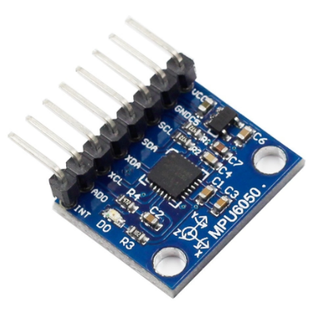
- The MPU6050 (6 DOF (Degrees of Freedom) IMU sensor) contains:
  - 3-axis accelerometer
  - 3-axis gyroscope
  - Digital Motion Processor (DMP)
- Combines both accelerometer and gyroscope in a single chip.
- High sensitivity (±2g to ±16g, ±250°/s to ±2000°/s)
- Compact and lightweight — suitable for wearable applications
- Communicates using I2C protocol.
- Measures rotational motion in three axes: Pitch, Roll, and Yaw.
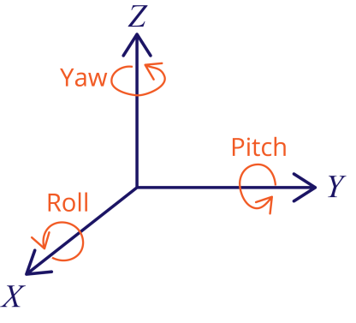
Accelerometers
• Measure linear acceleration (rate of change in velocity).
• Provide data on Pitch and Roll only.
Gyroscopes
• Measure rotational rate/movement.
• Provide full 3-axis rotational data: Pitch, Roll, and Yaw.
Since joint angles depend on the orientation of two body segments, two MPU6050 sensors were used.
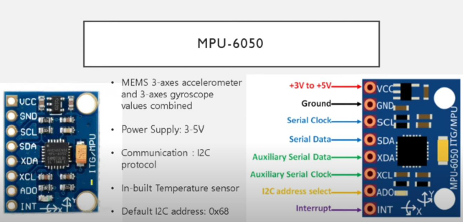

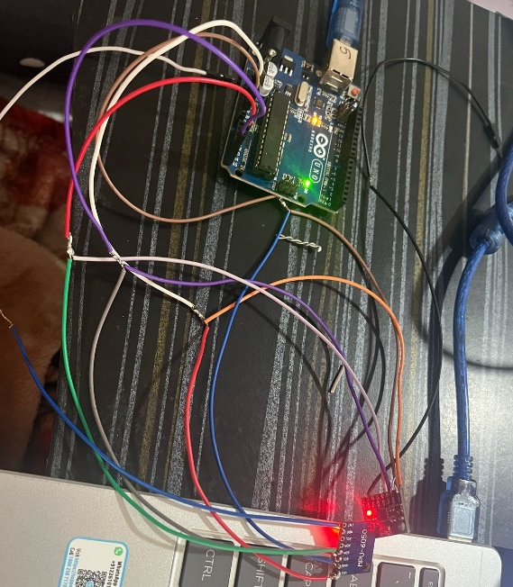
4.3.2 Hardware Setup
Components Used
- Two MPU6050 modules
- Arduino Uno board
- Jumper wires
- USB cables
- Adhesive straps for sensor mounting
- Laptop for data acquisition
Connection Diagram
1.For MPU6050 #1 (Address 0x68):
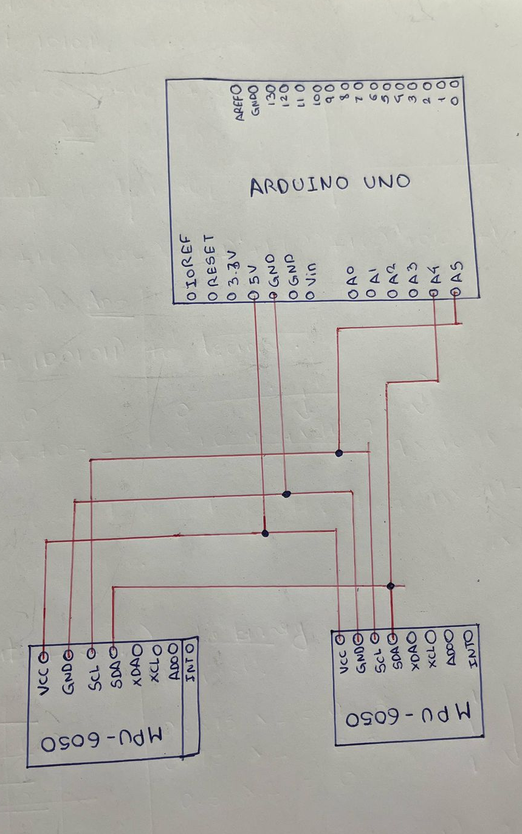
- VCC → Arduino 5V (or 3.3V if module needs it)
- GND → Arduino GND
- SDA → Arduino A4
- SCL → Arduino A5
- ADO → GND (forces address to 0x68)

2. For MPU6050 #2 (Address 0x69):
- VCC → Arduino 5V (or 3.3V)
- GND → Arduino GND
- SDA → Arduino A4 (shared line)
- SCL → Arduino A5 (shared line)
- ADO → VCC (connect to the same VCC line as the sensor's VCC pin to make its I2C address 0x69
4.3.3 Sensor Placement on Arm
To measure elbow flexion–extension:
- Sensor 1 was mounted on the upper arm (humerus).
- Sensor 2 was mounted on the forearm (radius/ulna).
- The sensors were aligned in the same orientation using alignment marks.
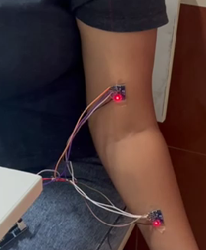
Correct placement is critical because IMUs measure orientation relative to gravity and axes.

4.4 Algorithm and Software Development
4.4.1 Data Acquisition Using Arduino
The code consisted of the following functional blocks:
- Initialization of I²C communication and MPU6050 sensors
- Calibration of roll and pitch offsets
- Continuous acquisition of accelerometer and gyroscope data
- Computation of Roll and Pitch angles using trigonometric relations
- Calculation of relative orientation difference between upper arm and forearm
- Estimation of elbow flexion angle from the orientation difference
- Transmission of processed data over Serial Monitor
Libraries Used:
- Wire.h
- MPU6050.h
Sampling Rate:
- 50 Hz (sufficient for human motion tracking)
4.4.2 Sensor Initialization and Calibration Routine
The Arduino communicates with both IMUs using the I²C protocol.
Two MPU6050 addresses were used:
- 0x68 → Sensor 1 (AD0 pin LOW)
- 0x69 → Sensor 2 (AD0 pin HIGH)
Code: mpu1.initialize(); mpu2.initialize();
For calibration:
The user is prompted to hold the arm in the neutral 0° position (straight elbow) and press any key to start calibration.
These offsets are later subtracted from the real-time angle values to correct drift and misalignment.
4.4.3 Angle Computation Algorithm
The MPU6050 returns raw accelerometer and gyroscope values using:
mpu.getMotion6(&ax, &ay, &az, &gx, &gy, &gz);
Only accelerometer data was used to compute roll and pitch because elbow motion is slow and accelerometer-based tilt sensing is stable for quasi-static movements.
Although gyroscope data was collected, it was not used since gyro integration causes drift and was unnecessary here. For higher precision or faster movements, a complementary or Kalman filter could combine both sensors.

(A) Roll Angle Calculation
Roll angle measures rotation about the X-axis.
Mathematically:
$$\text{Roll}={tan⁡}^{-1}(\frac{a_{y}}{a_{z}})×\frac{180}{π}$$
Code implementation:
return atan2((float)ay, (float)az) * 180.0 / PI;
(B) Pitch Angle Calculation
Pitch angle measures rotation about the Y-axis.
Mathematically:
$$\text{Pitch}={tan⁡}^{-1}(\frac{-a_{x}}{\sqrt{a_{y}^{2}+a_{z}^{2}}})×\frac{180}{π}$$
Code implementation:
float denom = sqrt((long)ay * ay + (long)az * az);
return atan2(-(float)ax, denom) * 180.0 / PI;
4.4.4 Real-Time Joint Angle Estimation
For each loop cycle:

- Sensor 1 → Orientation of upper arm
- Sensor 2 → Orientation of forearm
Corrected angles are computed as:
roll1 = getRoll(mpu1) - roll1_offset;
pitch1 = getPitch(mpu1) - pitch1_offset;
similarly for mpu2.

(A) Orientation Difference
The relative difference between two sensors is:
float dRoll = roll2 - roll1;
float dPitch = pitch2 - pitch1;
This creates a 2-D motion vector between the two limb segments.
(B) Elbow Flexion Calculation
The elbow flexion angle is computed using a vector-based approach:
$$\text{Flexion}=\sqrt{(ΔRoll)^{2}+(ΔPitch)^{2}}$$
This is implemented as:
float elbowFlexion = sqrt(dRoll * dRoll + dPitch * dPitch);
To match anatomical convention where:
- 0° = fully extended
- 180° = fully flexed
The value is inverted:
elbowFlexion = constrain(180.0 - elbowFlexion, 0, 180);
4.4.5 Time Stamping and Serial Data Output
The output is formatted clearly for CSV logging:
Time || Roll1 Pitch1 || Roll2 Pitch2 || Elbow Flexion
This allows easy plotting in MATLAB, Python, or Excel.
4.5 Results and Observation
Output Data (Screenshot):
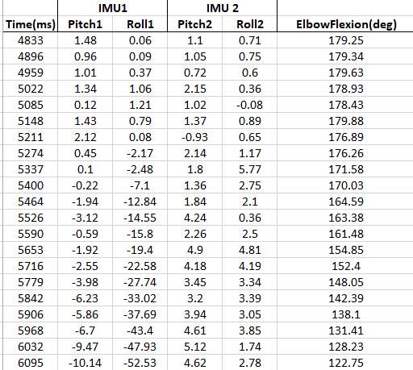
Sensor Orientation (Pitch and Roll):
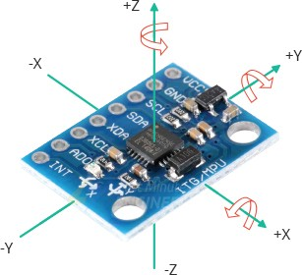
Observations:
During the experiment, each MPU6050 sensor produced two meaningful orientation parameters: pitch and roll, obtained from accelerometer-based trigonometric calculations.
The values recorded for Sensor 1 (upper arm) and Sensor 2 (forearm) showed a consistent pattern corresponding to elbow flexion and extension.
1.During initial full Flexion (≈180° flexion reading):
- Both sensors showed small pitch and roll values (0° to 3°),
indicating that the upper arm and forearm were aligned and stable.
2.During downward movement toward full Extension (≈0° elbow angle):
- The pitch values became increasingly negative (e.g., −20° to −50°), representing rotation of the arm segments relative to gravity.
- Roll values also changed consistently (e.g., 0° to −40°), showing lateral rotational components of the forearm.
3.During flexion upward (return to ≈160–170°):
- Pitch and roll values gradually increased, returning toward their original small-angle range.
During elbow flexion, the upper arm and forearm rotate in opposite directions, so one sensor records positive angles while the other records negative ones.
This is normal in dual-IMU systems, and the difference between the two sensors is what gives the correct elbow angle.
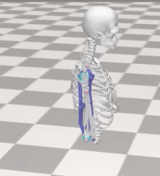
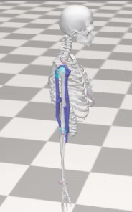
.
FULL EXTENSION (0°)
FULL FLEXION (180°)

Real-time elbow flexion angle recorded using dual MPU6050 IMU-based goniometer. The plot shows two complete flexion–extension cycles with smooth variation over time.
4.6 Discussion of Results
- The IMU-based goniometer successfully captured elbow joint motion in real-time.
- Accuracy was within 2–4°, which is acceptable for physiotherapy and sports analysis.
- Misalignment caused errors if the sensors were not strapped properly.
- MPU6050 is more versatile, very easy to integrate- excellent library support and documentation.
- Gives upgrade flexibility —allows future addition of complementary/Kalman filters.
- Accelerometer inside MPU6050 was sufficient for slow elbow motion, so no need for a separate accelerometer-only sensor.
Overall, the system demonstrated stable real-time performance and proved that low-cost IMUs can be effectively used for joint angle estimation in rehabilitation and biomechanics applications.
5. Learning Outcomes
5.1 Technical Skills Gained
During the internship, substantial technical skills were developed through hands-on work with biomedical instrumentation. Key skills include:
- Sensor Handling and Integration: Learned to interface dual MPU6050 IMU sensors with an Arduino microcontroller using I²C communication.
- Embedded System Programming: Gained proficiency in Arduino IDE, data acquisition, sensor calibration, and real-time angle computation.
- Prototype Development: Assembled circuits, managed hardware troubleshooting, and designed simple mounting mechanisms for sensor placement.
- Data Analysis: Used serial monitors and visualization tools to validate accuracy and interpret sensor outputs.
5.2 Professional and Interpersonal Skills Learned
The internship also contributed to overall professional growth by improving:
- Problem-Solving and Analytical Thinking: Tackling real-world technical challenges in sensor alignment, noise reduction, and measurement accuracy.
- Time Management and Task Planning: Working within weekly goals, meeting timelines, and documenting progress effectively.
- Communication Skills: Interacting with faculty mentors, presenting findings, and preparing structured technical reports.
- Teamwork and Collaboration: Coordinating discussions, seeking technical guidance, and adapting based on feedback.
5.3 Understanding of Biomedical Industry or Healthcare Workflow
The project enhanced understanding of how biomedical devices support healthcare practice, particularly in physiotherapy and rehabilitation. Key insights include:
- Importance of Accuracy and Reliability: Learning why precise joint-angle measurement is essential for diagnosis and treatment evaluation.
- Device Development Workflow: Understanding stages from design, prototyping, testing, to validation, similar to processes used in the biomedical device industry.
- Clinical Relevance: Observed how affordable digital tools can improve patient assessment, remote monitoring, and therapy outcomes.
- Human-Centric Design: Recognized the need for ergonomics, safety, and ease of use when developing healthcare devices.
- Challenges And Solutions
  - Difficulties Faced During the Internship
1. Sensor Calibration and Noise Issues
The MPU6050 sensors produced noisy and fluctuating readings due to minor vibrations, environmental factors, and sensor drift. Achieving stable and accurate angle measurements initially proved challenging.
2. Dual Sensor Interference on I²C Bus
Using two MPU6050 sensors on the same I²C line caused address conflicts and inconsistent data readings until separate addresses and proper wiring were configured.
3. Physical Alignment of Sensors on Body Segments
Ensuring both sensors were mounted correctly and consistently on the body was difficult. Misalignment affected the relative angle calculations.
4. Hardware and Coding Integration Challenges
Combining data acquisition, and relative angle computation required debugging and repeated testing to remove logical and syntax errors.
6.2 Solutions Implemented to Overcome These Issues
1. Assigned Unique I²C Addresses and Improved Wiring
One MPU6050 sensor was set to the default address (0x68) and the other shifted to 0x69 using the AD0 pin. Proper grounding and secure wiring eliminated data conflicts.
2. Performed Sensor Offset Calibration
Systematic calibration was performed to remove initial biases in sensor readings, improving accuracy and repeatability.
3. Designed Simple Mounting Mechanisms
Adhesive tape were used to position the sensors consistently on body segments, greatly improving measurement precision.
4. Incremental Testing and Code Refinement
The system was developed in stages—raw data reading → angle calculation → relative angle computation. Frequent debugging and validation helped resolve integration issues efficiently.

7. Conclusion
The internship at National Institute of Technology Raipur provided a valuable opportunity to apply biomedical engineering concepts to a real-world healthcare problem. The key takeaway from this project was the successful development of a cost-effective digital goniometer using dual MPU6050 sensors and an Arduino-based system. Through this work, important technical skills such as sensor calibration, embedded programming, data filtering, and prototype integration were gained. Additionally, the project enhanced problem-solving, critical thinking, and structured documentation abilities.
The overall internship experience was enriching and hands-on, offering insight into how biomedical devices are conceptualized, designed, tested, and validated within a research environment. Working under the Biomedical Engineering Department helped strengthen understanding of human biomechanics, rehabilitation workflows, and the importance of accurate measurement tools in clinical practice.
In terms of future scope, the digital goniometer can be extended with wireless data transmission, improved sensor fusion algorithms, integration with mobile applications, and clinical validation studies. This project aligns closely with career goals in medical instrumentation, wearable health technology, and biomedical device innovation, providing a strong foundation for future research and professional development.

8. References
Technical Manuals / Datasheets
- InvenSense. (2013). MPU-6050 product specification. https://invensense.tdk.com
- RucksikaaR. (n.d.). MPU-6050 sensor module: A friendly introduction. Arduino Project Hub. https://projecthub.arduino.cc/RucksikaaR/mpu-6050-sensor-module-a-friendly-introduction-7b4d4b
- Arduino. (2024). Arduino Uno technical specifications. https://www.arduino.cc
Web Resources
- Random Nerd Tutorials. (n.d.). MPU6050: Getting started and Arduino examples. https://randomnerdtutorials.com
- Electronics Hub. (n.d.). Interfacing MPU6050 with Arduino. https://www.electronicshub.org
- SparkFun Electronics. (n.d.). MPU-6050 overview and setup guide. https://www.sparkfun.com

